Institución Educativa Monseñor Ramón Arcila
Subject: English. 1st. Term.
Student’s full name: ___________________________________
Date: march 16th, 2020
Taller para todos los grupos de 9°, jornada de la tarde.

EL TRABAJO SE HABÍA PENSADO GRUPAL PERO, POR DIRECTRICES DE ORDEN NACIONAL, LA RECOMENDACIÓN ES PERMANECER EN CASA; POR LO TANTO, EL PRESENTE TALLER DEBERÁ SER REALIZADO INDIVIDUALMENTE.

Instrucciones:

- Cada estudiante podrá escoger, entre los siguientes 6 textos, aquel que más le interese.
- Una vez escogido el texto, deberás leerlo (y entenderlo) para hacer una cartelera (de un pliego) en la que aparezca: el título del texto escogido y dos columnas con los aspectos positivos y negativos que presenta cada texto. Escoger un máximo de 5 aspectos positivos y 5 aspectos negativos (cuando se habla de aspectos, también se puede entender como “pros” y “contras”, beneficios y retos, etc.).
- Deberán tomar una fotografía de la cartelera y enviarla al correo: lectexaca@hotmail.com o ataraxia0@hotmail.es . Por favor, identifíquese con nombre completo y grado al que pertenece. La cartelera física (es decir, en el pliego) deberá ser llevada al colegio una vez se normalice la situación y reiniciemos clase presencial). La fecha límite de entrega virtual (es decir, a los correos aquí mencionados) será el día viernes 27 de marzo.
- La elaboración de la cartelera equivaldrá a una nota del período; la presentación oral de la cartelera física, al regresar de esta situación, tendrá también su nota correspondiente e independiente de la cartelera. Estar preparados: tienen tiempo más que suficiente.
- Tanto la cartelera como la presentación oral se realizarán en idioma Inglés, obviamente. Para la cartelera deben usar lenguaje muy sencillo, oraciones cortas. Para la presentación oral, podrán hacer aclaraciones en español, pero lo que aparece en la cartelera deberá decirse en Inglés: practicar con herramientas virtuales como Google translator para pronunciación.

Estos son los títulos de los textos que se encuentran en este mismo documento:

- Ciberbullying
- The pros and cons of social networks
- 5 Pros and Cons of Using Technology in your Classroom
- Telehealth: the benefits and challenges
- The effects of IT on employment
- The pros and cons: online shopping

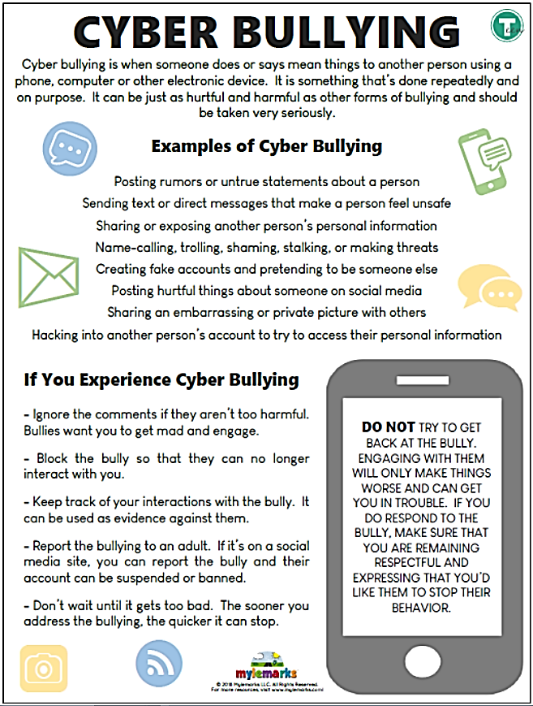
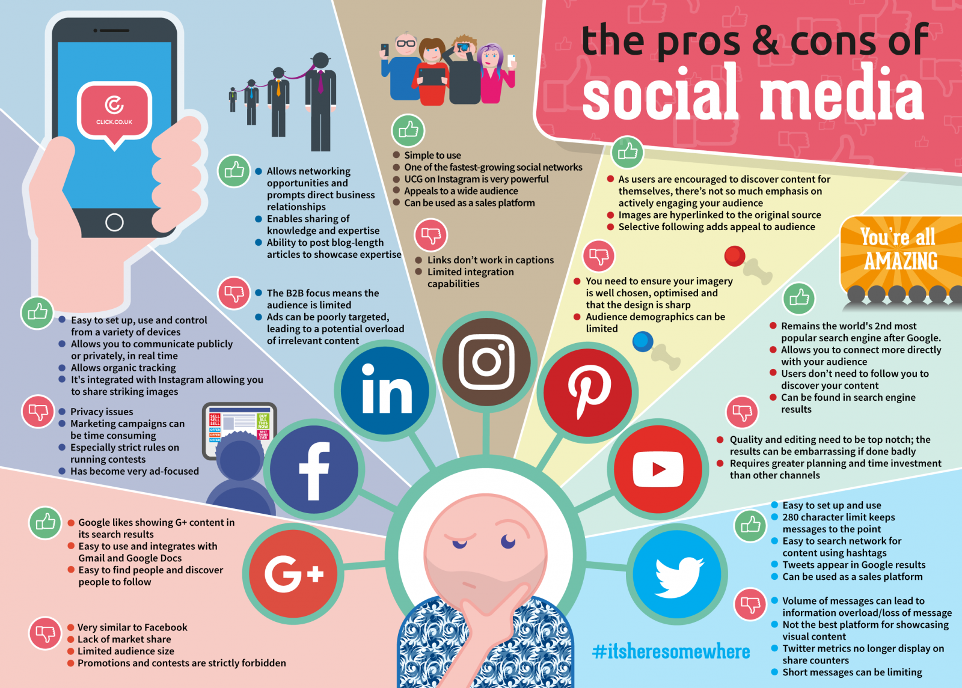

5 Pros and Cons of Using Technology in your Classroom
Pros of Technology in the Classroom
- Independent learning for students
Teachers could assign the task for students in the group and encourage them to complete in a single group by using the technology and check out on the academic queries if arises. It’s quite easy to connect students with the help of technology. Naturally, you could find many of students who are shy and don’t feel comfortable in sharing their views, but when once they have to complete the task in a group, they would prefer to open up with each other. There are few tools like Piazza, which could be used for achieving such goals of making shy candidates share their view points. The group which is created could be divided into small sections with around 4-5 candidates. They have the quick accessibility and are well-equipped with the knowledge and skills of operating the technology for their benefit.
- Visual illustrations- make learning easier
In case if the classroom is equipped with technology and every individual has his own system with them, the lessons could be showcased in the visual format. It allows you to experiment more in the pedagogy. Whether it’s going to be dramatic change which could include teaching with the flipped classroom, or by just adopting a specific tool for focusing on team or the project. If you are well versed with the technology, then you would be able to build the credibility with students and even with the fellow colleagues.
- Effective means of learning
Technology in your classroom is designed for making the learning easy and bit quicker. Its efficiency allows the candidates to grasp the concepts in the shorter span of time and inevitably allows them to learn much more than expected, when technology would not have been used. It not only enhances the caliber of the candidates but also provides deeper insight to the instructors across.
- Life skills via technology
Using technology in classroom could prepare your students for their deep rooted future with enhanced technologies hitting into the market. The vital skills like as focusing on creating presentation, maintaining proper etiquette, writing emails etc. which could be inculcated in the classroom.
- Creativity is enhanced and focused upon
All the candidates don’t believe in going through the text books, due to which they are not efficient or quick learners. There are few students who do require the creativity for stimulating their potential learning. The best thing about the technology in classroom is that it is able to help those students who are interested in learning things in creative and innovative manner.
Cons for Technology in the Classroom
- Technology could be distraction
The technology could be a distraction, majorly when the candidates are using for the personal reasons while class is going on. The only means how it could be managed is by settling down with the specific set of rules and regulations for classrooms. Failure to comply with the terms, students would be at great risk of learning and losing his system.
- Disconnection with Social Media
Quite of people are skeptical of the technology and what it is doing to student’s ability of verbally communicating. In case if you are creating assignments in the class which are using both technology tools and oral presentations, it would enhance the caliber of candidate to be dynamic and to check out that how they interact and learn with others.
- Online security and Safety
One of the major concerns is with regards to security and safety of students as they should not be able to access the unsuitable materials. It is due to the security that most of the search engines are providing facilities of filter for removing unwanted content on the site.
- Forgetting the basic ways of studying
The candidates are no longer going to rely on books which are shared by their seniors for them to study. They are inclined to enhance their knowledge the use of the technology. Even the simple problems and homework assigned to them are answered with the help of the technology and don’t use their mind at all.
- Decade of change in the classroom
Its last decade when the ample of changes with respect to classroom with technology has taken place. Such kind of infusion of technology goes much beyond that of computers. Technological devices and internet has changed the means of learning which are taking place. Traditional methods of education are no longer the norm and now technology is root for almost all the lessons taught or methods of education.

TELEHEALTH: THE BENEFITS AND CHALLENGES
What is telemedicine?
Think of telemedicine as the “modern-day version of the doctor’s house call.” Patients are able to access top-notch medical care from a computer, smart phone, or tablet. It’s the best way to provide care while negating the need for an in-person visit. According to Solv Health this technology can be used in many different ways including, prescription management, consultations, follow-ups, and chronic health management. Naturally, telemedicine is the next step in providing patients with much needed quick and affordable care. Some specific treatments and consultations that are provided include, telepsychiatry, teledermatology, and telerehabilitation.
What are the Benefits?
There are various benefits which make telehealth an excellent option for many patients:
Time Saving – Overall telehealth cuts down on the time spent getting to and from the office and waiting for your doctor. You can simply log onto the telemedicine system and get high quality care in minutes. Using telemedicine keeps you from having to leave work to receive the health information you need. Additionally, communicating with a doctor over your smartphone or tablet gets rid of the risk of getting an illness or infection from another patient in the waiting room.
Affordability – Visits using telemedicine don’t require the use of as many resources as a traditional office visit. This makes it more affordable for all parties involved.
Accessibility – Telehealth makes it possible for everyone to receive the care they need at the touch of a button. This is even more prevalent in rural communities where access to healthcare is slim. Patients don’t have to worry about traveling to a facility that’s far away; they can now reach a doctor right on their phone.
Access to Specialists – The technology of telehealth also makes seeking out care from specialists much easier. Patient no longer have to drive hours to another state to connect with the doctors they need. An increased access to specialists, is not only time saving, but also convenient for all parties.
What are the Challenges?
Even though there are multiple benefits to telehealth, there are also some challenges that come with this new technology:
Not Suitable for All – Let’s face it, there are some healthcare needs that do require an in-office visit. With telemedicine you can get a “swift evaluation of your symptoms with on-demand telemedicine, but you can’t get a full, routine physical exam,” according to the Cleveland Clinic. There are also tests that require the patient to come into the office.

Technology Problems – No matter where you are, there will always be problems with technology every now and then. Losing power, a bad connection, or even a dead battery can interrupt the call. If call quality is affected the care a patient is seeking may not be fulfilled.

Not Offered Everywhere – Telehealth is still a new technology and not all healthcare providers have this service. This is because some are still hesitant about providing care over a phone or tablet. Doctor’s worry that the same quality of care can’t be provided.

The effects of IT on employment
Manufacturers used to employ millions of people, but nowadays:
- Skilled workers such as technicians and machine operator maybe replaced by computer-controlled robots, which can work quicker and more consistently, for more hours.
- Dirty and dangerous jobs have been replaced by equipment fitted with sensors that monitor the environment and report issues.
Office personal used to think that their jobs were relatively safe, but:
- Databases have been enable offices to store data electronically. One person with a database is able to manage quantities data, so there is no longer any need for filing clerk.
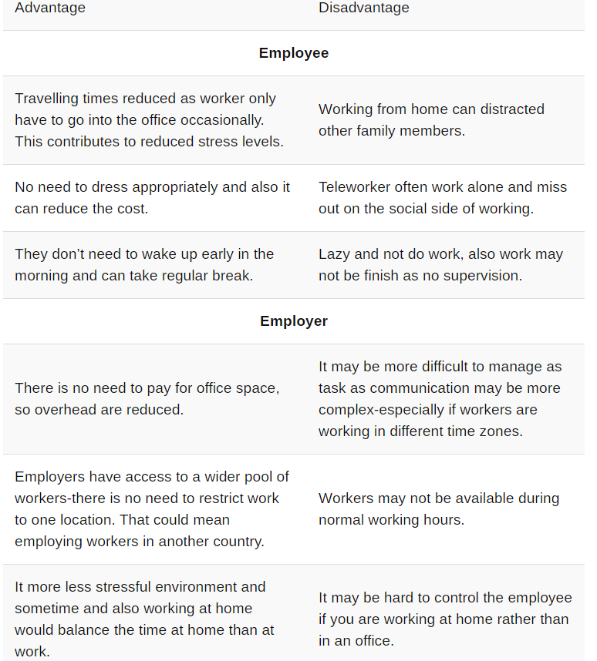
- Payroll calculation that were carried out by large numbers of clerks can now be done by one person with spreadsheet.



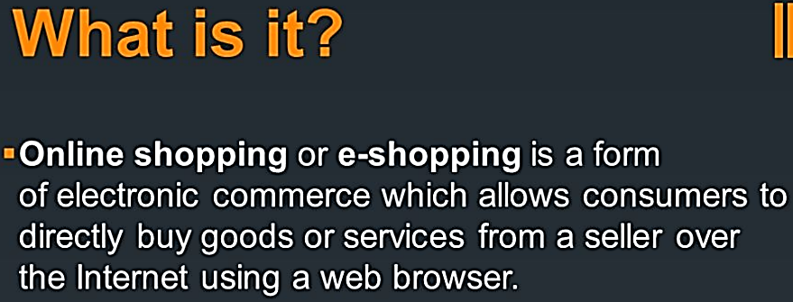

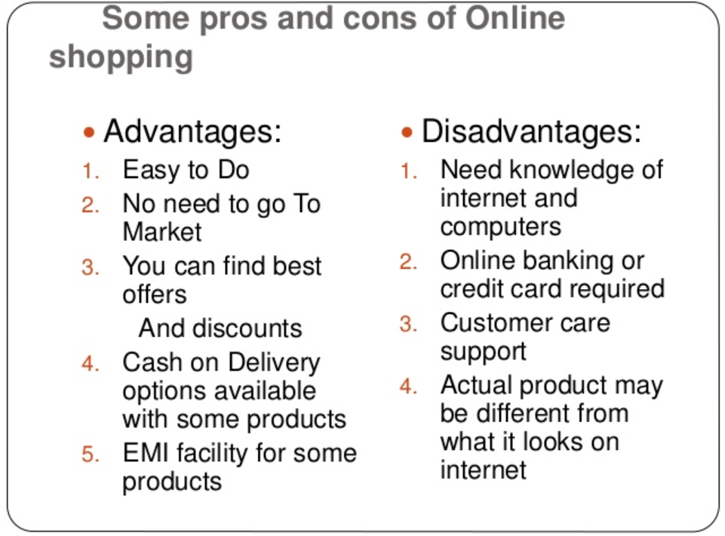
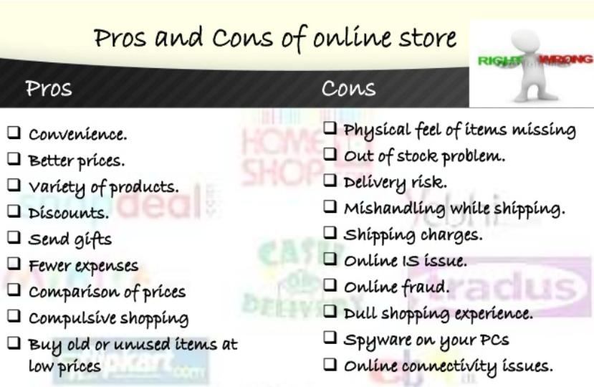

https://www.click.co.uk/resource/the-pros-cons-of-social-media/
https://edtechreview.in/trends-insights/insights/2064-pros-and-cons-of-technology-in-the-classroom
http://leonardoddo.com/telehealth-the-benefits-and-challenges/
https://igcseicttan.wordpress.com/5-1-the-effects-of-it-on-employment-2/
https://pros-and-cons-online-sho-qqq.peatix.com/
https://lucyaedwards.wordpress.com/2017/03/07/ecommerce-websites-vs-brick-and-mortar-shops/

